Lecture 1
Introduction to Academic Writing
Contents
- What ls Academic Writing?
- What ls a Paragraph?
- Prewriting Activity: Asking Questions and Taking Notes
- A special form for paragraphs
- The rules for correct paragraph form
- Editing Paragraph Form
- Sample Writing Task 1
- Review Questions

What ls Academic Writing?
The kind of writing you will do in this class is called academic writing because it is the kind of writing you do in college classes. Every kind of writing has a particular purpose and a particular audience. The purpose of academic writing is to explain something or to give information about something. Its audience is your teacher and your classmates.
Academic writing requires certain skills. These skills include sentence structure (how to arrange words in a sentence), organization (how to arrange ideas in a paragraph), and, of course, grammar and punctuation. Each chapter of this book has sections with a lesson and practices for each skill. At the end of each chapter, you will write a paragraph using the skills you have just learned.

What Is a Paragraph?
A paragraph is a group of related sentences about a single topic. The topic of a paragraph is one, and only one, idea.
A paragraph has three main parts.
I . Topic sentence - The first sentence in a paragraph is a sentence that names the topic and tells what the paragraph will explain about the topic. This sentence is called the topic sentence.
2. Supporting sentences - The middle sentences in a paragraph are called the supporting sentences. Supporting sentences give examples or other details about the topic.
3. Concluding sentence - The last sentence in a paragraph is called the concluding sentence. A concluding sentence often repeats the topic sentence in different words or summarizes the main points.
A paragraph is like a cheeseburger sandwich: two pieces of bread (the topic and concluding sentences) enclosing the filling (the supporting sentences). https://www.youtube.com/watch?v=gNUw5CqfGak
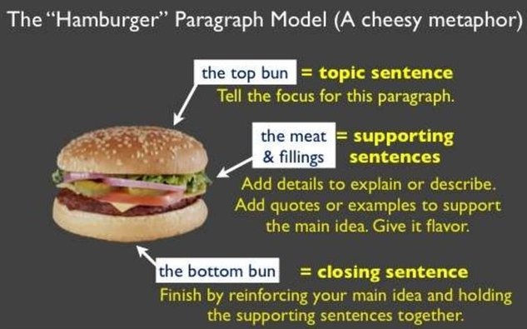
Each paragraph that you write for this class should also have a title. A title tells the topic of the paragraph in a few words. A title is short. It is not a complete sentence. It may be just one word. Here are some examples of titles.
- My Classmate
- Friendship
- A Famous Soccer Player
As you read the following model, look for the three parts of a paragraph. For now, just remember that a paragraph has three parts.
Paragraph 1
Mrs. Robinson
1 My first grade teacher was an important person in my life. 2 Her name was Mrs. Robinson. 3 ln the schools in my country, children usually learn to print before they learn to write. 4 Mrs. Robinson didn't believe in printing. 5 She thought it was a waste of time. 6 She taught us to write in cursive script (like handwriting) from the first day. 7 At first it was hard. 8 She made us practice a lot. 9 I remember filling entire pages just with capital Os. 10 At the end of the year, we felt very grown up because we could write in cursive. 11 Mrs. Robinson was important in my life because she taught me a valuable lesson. 12 I can achieve anything by working hard.

Prewriting Activity: Asking Questions and Taking Notes
Whenever you write, you need ideas to write about. Taking notes is one way to get ideas. You may ask some questions and take notes about the answers. When you take notes, you do not have to write complete sentences. Just write down the important information.
Sample Questions | Sample Notes of Classmate Responses
Where are you from? | Michoacan. Mexico
How long have you lived in this country? | 2 years

A special form for paragraphs
In academic writing, there is a special form for paragraphs. When you write a paragraph, make it look like the one below.
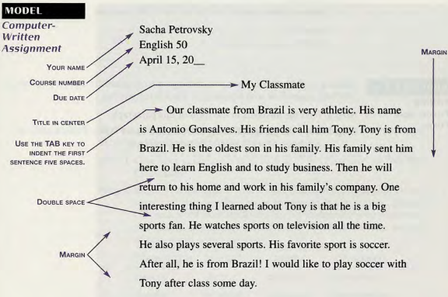

The Rules for Correct Paragraph Form
Here are the rules for correct paragraph form for a paragraph typed on a computer.
I. Paper
Use А4 white paper.
2. Font
Use a standard font style, such as Times New Roman. Do not use underlining, italics, or bold type to emphasize words. It is not correct to do so in academic writing.
3. Heading
Type your full name in the upper left corner. On the next line, type the course number. On the third line of the heading, type the date the assignment is due in the order month-day-year, with a comma after the day.
4. Assignment Title
Skip one line, and then center your title. Use the centering icon on your word processing program.
5. Body
Skip one line, and start typing on the third line. Indent (move to the right) the first line of each paragraph by using the TAB key. (The TAB key automatically indents five spaces.)
6. Margins
Leave a l-inch margin on the left and right margins.
7. Spacing
Double-space the body.

Editing Paragraph Form
Editing is what you do when you check your writing and correct and improve it. Work by yourself or with a partner on this editing practice.
Step 1 Find the mistakes in the form of this paragraph.
Step 2 Copy the paragraph using correct form on an А4 piece of paper. It should be one paragraph.

Sample Writing Task 1
Writing about a Groupmate
Step 1 Give your paragraph a title
Step 2 Begin your paragraph with a topic sentence that tells your classmate's name and also describes his or her personality in general.
Step 3 Write several sentences telling about your classmate. Use your notes to make sentences.
Step 4 End your paragraph with a concluding sentence that tells how you feel about your classmate.
Step 5 Check your paragraph.
Step 6 Write a neat final copy of your paragraph to hand in to your teacher.

Review Questions
What is academic writing?
What is a paragraph? (definition, structure, etc.)
Can a paragraph discuss more than one topic?
What are the three parts of a paragraph?

